**Project Planning Phase**

**Project Planning Template (Product Backlog, Sprint Planning, Stories, Story points)**

|  |  |
| --- | --- |
| Date | 27 June 2025 |
| Team ID | LTVIP2025TMID20380 |
| Project Name | HouseHunt: Finding Your perfect rental home |
| Maximum Marks | 5 Marks |

**Product Backlog, Sprint Schedule, and Estimation (4 Marks)**

|  |  |  |  |  |  |  |
| --- | --- | --- | --- | --- | --- | --- |
| **Sprint** | **Functional Requirement (Epic)** | **User Story Number** | **User Story / Task** | **Story Points** | **Priority** | **Team Members** |
| Sprint- 1 | Registration | USN-1 | As a user, I can register with email, password, and type | 2 | High | Bhuvana  Team B |
| Sprint- 1 |  | USN-2 | As a user, I receive a confirmation email after registration. | 1 | High | Bhuvana |
| Sprint- 2 |  | USN-3 | As a user, I can register using Facebook. | 2 | Low | Team C |
| Sprint- 1 |  | USN-4 | As a user, I can register using Gmail. | 2 | Medium | Bhuvana |
| Sprint- 1 | Login | USN-5 | As a user, I can log in with my email and password. | 1 | High | Team D |

|  |  |  |  |  |  |  |
| --- | --- | --- | --- | --- | --- | --- |
| Sprint- 2 | Dashboard | USN-6 | As a user, I can view my listed properties and filter them and then book them | 3 | High | Team C |
| Sprint- 2 | Admin approval | USN-7 | As a admin I can approve or reject owner registration | 3 | High | Team D |
| Sprint- 3 | Add/Edit/Delete property | USN-8 | As a user I can add, edit or delete my listed properties | 4 | High | Team B |
| Sprint- 3 | Image upload and Testing | USN-9 | As a user, I upload property imsges and team can test whole app | 2 | Medium | Bhuvana  TeamB  Team D  Team C |

**Project Tracker, Velocity & Burndown Chart (4 Marks)**

**Project Tracker Table**

|  |  |  |  |  |  |  |
| --- | --- | --- | --- | --- | --- | --- |
| **Sprint** | **Total Story Points** | **Duration** | **Sprint Start Date** | **Sprint End Date (Planned)** | **Story Points Completed** | **Sprint Release Date (Actual)** |
| Sprint-1 | 20 | 6 Days | 12 Jun 2025 | 18 Jun 2025 | 20 | 18 Jun 2025 |
| Sprint-2 | 20 | 6 Days | 19 Jun 2025 | 25 Jun 2025 | 18 (Estimated) | 25 Jun 2025 |
| Sprint-3 | 20 | 6 Days | 26 Jun 2025 | 31 Jun 2025 | TBD | TBD |

**Velocity Calculation**

**Formula:**

**Velocity = Total Story Points Completed / Number of Sprints**

* Sprint-1: 20
* Sprint-2: 18
* Sprint-3: 16
* Total Story Points = **54**
* Number of Sprints = **3**

**Team Velocity = 54 / 3 = 18 Story Points per Sprint**

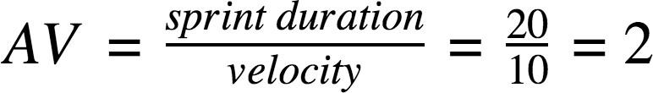

Team Velocity & Average Calculation

**Story Points Completed Per Sprint**

|  |  |
| --- | --- |
| **Sprint** | **Story Points Completed** |
| Sprint-1 | 20 |
| Sprint-2 | 18 |
| Sprint-3 | 16 |
| Total | 54 |

**Average Story Points per Day**

Assuming each sprint = **6 working days**, then:

**Average = Velocity / Sprint Duration**

Average = 18 story points / 6 days = **3 story points per day**

**BURNDOWN CHART EXPLANATION**

A **Burndown Chart** tracks the total remaining work (story points) against time (days). It helps monitor sprint progress and whether the team is on track to finish tasks within the sprint timeline.

* X-axis: Time (Sprint Days)
* Y-axis: Remaining Story Points
* Ideal line: Declines linearly from total points to zero
* Actual line: Shows real progress based on completed story points daily
* 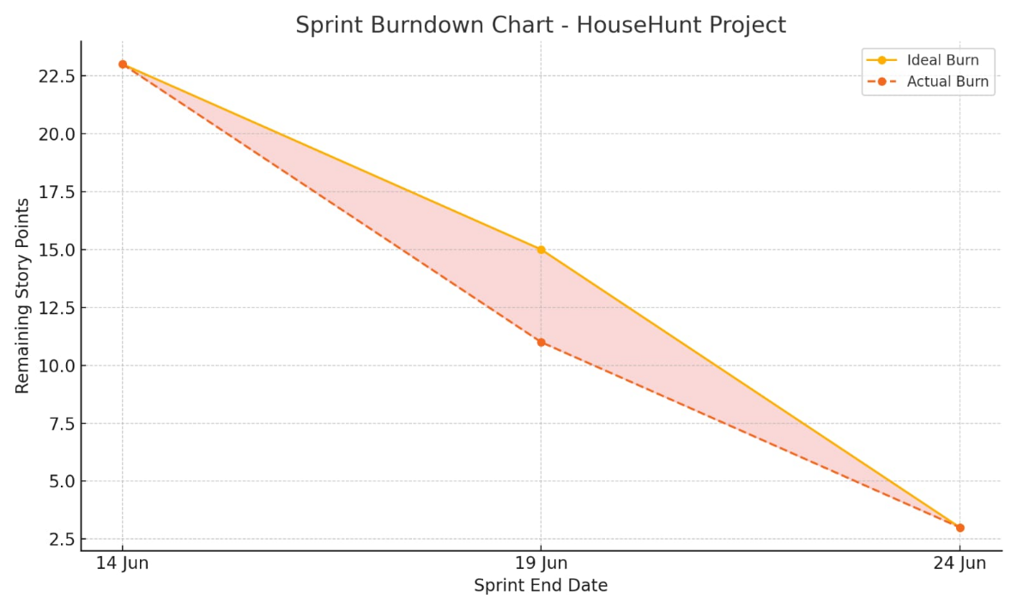

References

1. **Scrum Burndown Chart Overview**

<https://www.visual-paradigm.com/scrum/scrum-burndown-chart/>

1. **Burndown Charts Tutorial**

<https://www.atlassian.com/agile/tutorials/burndown-charts>

1. **Agile Project Management Guide**

<https://www.atlassian.com/agile/project-management>

1. **How to Do Scrum with Jira Software**

<https://www.atlassian.com/agile/tutorials/how-to-do-scrum-with-jira-software>

1. **Understanding Epics in Agile**

<https://www.atlassian.com/agile/tutorials/epics>

1. **Introduction to Sprints**

<https://www.atlassian.com/agile/tutorials/sprints>

1. **Agile Estimation Methods**

<https://www.atlassian.com/agile/project-management/estimation>